LEGO Crane Kit
Glen Bull, Jo Watts, and Moses Kumenya
The goal of this project is to use the parts provided in the Sangala Crane Kit to assemble a LEGO crane. The crane began as photograph that was translated into a mosaic of LEGO tiles using Sangala Mosaic.
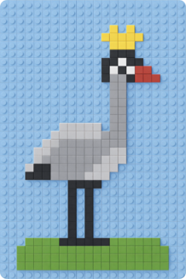
tiles using The digital plan for the mosaic of LEGO tiles was then imported into Sangala Studio and translated into a frame that was used to create a three-dimensional projection of the two-dimensional mosaic. This three-dimensional figure was used to create a 3D-printed crane. The 3D-printed crane (shown on the left below) was then imported into Sangala Blocks and used to design a three-dimensional figure composed of LEGO bricks (shown on the right below).
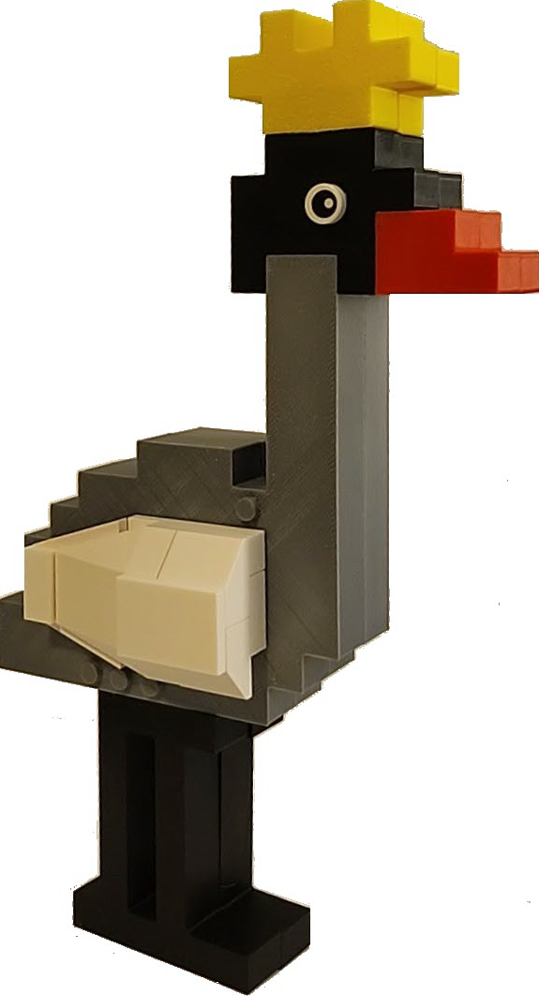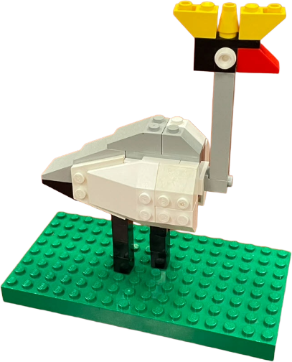
used to design The LEGO bricks in your Sangala Crane Kit are divided into bags containing the parts to assemble different elements of the LEGO crane, including the crown, the head, the body, the wings, and the legs. The completed three-dimensional LEGO figure is placed on a green LEGO baseplate.
The process of using three Computer-Aided Design (CAD) tools, Sangala Mosaic, Sangala Studio, and Sangala Blocks, facilitates the transition from two-dimensional design thinking to three-dimensional design thinking. The goal of this kit is to provide an example of the process that you can use to design your own LEGO kit beginning with a two-dimensional photograph.

